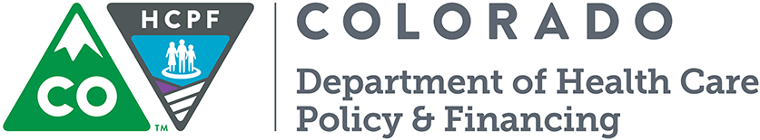
Child Welfare Incentive Template
  - FY 2018-19 County Incentives Program

County Contacts:
County: Choose Your County | Email: Click here to enter text.
County Contact(s): Click here to enter text. | Phone: Click here to enter text.

Collaboration Meeting Quarter and Date(s):

Select Quarter: Select a Quarter

Meeting Date(s): Enter Meeting Date

Child Welfare Meeting Goals:
Please list the 2-3 goals the county and the partner attendees would like to accomplish over the next year to improve members’ access to care:

1. Enter Goal 1

2. Enter Goal 2

3. Enter Goal 3

Supporting Documentation:
Please note all three supporting attachments – Agenda, Minutes, Sign-in Sheets, are required.
☐Agenda ☐Minutes ☐Sign-in Sheet ☐Other: Please Describe

Required and Optional Partner Attendees:
Please check all partner attendees that were invited to the county’s child welfare quarterly collaboration meetings

Required Child Welfare Quarterly Collaboration Partners
☐Representative from the Collaborative Management Program  ☐Representative from the county’s child welfare staff  ☐Representative from the Division of Youth Services (or local correctional representative if no DYS representative is available) | ☐Representative from the Regional Accountable Entity  ☐Representative from the county’s eligibility staff

Optional Child Welfare Quarterly Collaboration Partners
☐ Representative from Dependency & Neglect System Reform (DANCR)  ☐ Representative from Multisystemic Therapy (MST)  ☐ Other: Please Describe | ☐ Representative from Healthy Communities  ☐ Representative from Family Resource Centers

Please provide a narrative below and documentation if any required partner was unable to attend the county’s child welfare quarterly collaboration meetings:
Enter Any Additional Information Here

Department Contacts:
County Relations
HCPFCountyRelations@state.co.us
Colorado.gov/hcpf/county-admin

