Member Experience Advisory Council Development

Grant Application
  - Fiscal Year 2018-19 Client & Stakeholder Engagement Sub-Grant Program
Release Date: May 15, 2018

Instructions: Complete this Grant Application to be considered for participation in the Member Experience Advisory Council Development project.

Due Date: Close of business, Friday, June 29, 2018 to HCPFCountyRelations@state.co.us.

Table of Contents:
Project Description Section | Page #
Project Overview and Goals | 2
Who can apply? | 3
State Responsibilities | 3
County Responsibilities | 4
High-Level Project Plan | 5

Application Section
Part I – Key Contact Information | 6
Part II – Project Need | 6
Part III – Data and Metrics | 7
Part IV – Project Budget | 7
Part V – Tracking and Documentation | 9
Part VI – Sustainability | 10
Appendix A – Results and Recommendations from Counties Member Experience Project | 11
Appendix B – HCPF’s Member Experience Council Journey and Outcomes | 14
Appendix C – Application Process | 16
Appendix D – Scoring Process and Interview | 17
Appendix E – Conditions of Funding | 18

Project Description Section

Project Overview and Goals
In FY 2017-18, the Colorado Department of Health Care Policy and Financing (the Department) initiated a research project into the member experience at the county level in the Health First Colorado (Colorado’s Medicaid program) eligibility process. It was our intention that the project would yield a variety of discrete projects that county departments of human/social services could undertake to improve member experience for Health First Colorado recipients and their families (See Appendix A). One conclusion was that county partners could benefit from ongoing engagement with members wherein sharing their lived experiences could potentially improve eligibility operations specific to local needs. The Department has been operating a Member Experience Advisory Council (MEAC) for three years with positive results and changes made. (See Appendix B).

The goal of this project is to establish sustainable Member Experience Advisory Councils (Council) in counties or regions who apply, are selected, and agree to project guidelines. The Councils will advise on operational matters within the scope of responsibility of the county and aimed at improvement of the Health First Colorado member experience at the county. It is expected that the participating counties will use this input and will, when possible, make changes.

The term of this project will be from July 1, 2018 to March 15, 2019.

Who can apply?
County departments of human/social services or regional collaborations consisting of a group of counties can apply to participate in this project. For each accepted application, only one Member Experience Advisory Council will be formed.

State Responsibilities
The Department will:
- Review applications and select participants based on this application and the selection guidelines shared here
- Contract with an entity to facilitate the development of Councils in the counties that are participating. Facilitation will include:
  - Creating and facilitating a Development Workshop
  - Work with individual counties on recruitment
  - Facilitate 2-3 Council meetings
- Develop agenda (in consultation with the project manager)
- Prepare activities, materials
- Actively facilitate meeting event
- Prepare follow-up reporting including “to do” lists
  - Coach (shadow) county staff in facilitation of 2-3 Council meetings
  - Provide 4 hours additional support
- Manage contracts
- Create a project plan for the facilitator
- Observe Council meetings as coordinated with the facilitator
- Review required documentation for approval
- Disburse grant funds including
  - Reimburse travel for 2 workers from each participating county to attend a Development Workshop (no more than $1000/participating county)
  - Costs of holding at least 6 Council meetings (no more than $8000 per Council), which MAY include:
    - Travel reimbursements for members
    - Technology costs
    - Incentives for members
    - Food/Beverage
    - Translation services
    - Child Care reimbursements for members
    - Supplies
- Support continued Council activities by sharing information, best practices, providing guidance and advice upon request.

County Responsibilities
Participating county departments of human/social services will:
- Apply for the grant opportunity following all guidelines and deadlines contained in this document
- Submit letters of support from county director(s) or designee(s) upon approval (if the application was authored by someone other than the director)
- Commit to assigning a project manager to lead the project work at the county level
- Send 2-3 employees per participating county (including the project manager) to a Development Workshop
- Actively assist the facilitator in recruiting Health First Colorado members or their family members to serve on their Council
- Commit to holding at least 6 Council meetings during the grant period
- Document member input and how it is used
- Commit to using input from the Member Experience Advisory Council to improve operations at the County
- Submit quarterly reports per the project plan
- Submit documentation of expenses
- Commit to continuing engagement with the Member Experience Advisory Council for at least one year after the grant period.
- Agree to requirements stated in the final Award Letter/Conditions of Funding document
- Make an effort to have 1 county representative per participating county to attend/participate in the annual grants report-out session in June 2019 (Granted project funds cannot be used to support this travel as it will occur after the grant has closed)

High-Level Project Plan
 | Participating Counties | State
FY 2017-18
Quarter 4 | - Submit Applications | - Select Participating Counties
FY 2018-19
Quarter 1 | - Sign Award Letter / Conditions of Funding document  - Obtain Leadership Buy-in  - Send 2–3 County Representatives to Development Workshop  - Assist Facilitator with recruitment  - Submit Q1 Progress Reports | - Contract with Facilitator  - Contract management
Quarter 2 | - Initiate Member Experience Advisory Council Meetings with Facilitator  - Submit Q2 Progress and Expense Reports | - Observation of Council meetings  - Contract management
Quarter 3 | - Continue Member Experience Advisory Council Meetings with Facilitator Input  - Submit Q3 Progress and Expense Reports  - Submit project plan for continued Council meetings  - Submit any Final Reports requested by the State | - Observation of Council meetings  - Contract management

Application

Part I – Key Contact Information
What County or Counties are applying for this Project?

Grant Project Manager
(the individual who will be responsible for managing this project at the County level)
Name
Phone
Email
Additional Project Contact (if applicable)

Name
Phone
Email

Part II –Project Need

Provide your vision and hoped-or benefits of a Member Experience Advisory Council in your county/area. Provide a detailed explanation of the county’s unmet needs for member input and how this project will address those needs. Please include examples of areas of county operations that could be addressed or improved by this project.

Maximum Score = 3 Points
Describe the Need for a Member Experience Advisory Council in your County (500 words or less)

Part III – Data & Metrics

Data and Metrics: Current and Future State
Describe the data and metrics that will be tracked to identify the project’s success. Maximum Score = 3 Points
Describe the Data and Metrics you propose to use to determine success. (500 words or less)

Data and Metrics: Measuring and Tracking Goals and Objectives
Describe the intended plan for measuring and tracking goals and objectives of the project, identifying the individual(s) responsible for each activity.
Data and/or Metric | Responsible Individual
Enter data/metric | Responsible Individual(s)
Enter data/metric | Responsible Individual(s)
Enter data/metric | Responsible Individual(s)

Part IV – Project Budget

Feasibility and Reasonableness of the Budget
- Provide a narrative that explains how the budget categories and amounts were determined.
- Describe any intended inclusion of county resources dedicated to the project, identifying these resources as county-provided.

Please provide a Budget Narrative. (500 words or less)

Itemized Budget
- Provide a budget that includes the best estimate of a detailed itemization of project costs including personnel and other items directly associated with the implementation of the project. Costs may include:
    - Travel reimbursements for members
    - Technology costs
    - Incentives for members
    - Food/Beverage
    - Translation services
    - Child Care reimbursements for members
    - Supplies

- Development Workshop travel costs for travel for 2 individuals per participating county to the Department’s office in Denver, CO should be included in the Itemized Budget. See Appendix E, Conditions of Funding, for more information.

- The State will grant no more than $8000 per Council for these project costs plus no more than $1000 per participating County to support travel for 2 individuals for attendance at the Development Workshop. Costs exceeding the granted amount will be the responsibility of the county incurring the costs through county only funds.

Provide a budget in the following table and expand as needed.
ITEM  BRIEF DESCRIPTION | RATE AND UNIT OF MEASURE | QUANTITY | TOTAL FOR PROJECT
EXAMPLE  AA Software | $400.00 per license | 2 licenses | $800.00
Development Workshop – Travel Costs for 2 individuals per participating County
PROJECT BUDGET TOTAL

Part V – Tracking and Documentation
Expenditures associated with awarded grant funds must be tracked and accounted for separately from other county administrative expenditures. Please describe the methodology you will utilize to track these expenditures. This should include funds spent, allocation and time tracking of staff, and documentation kept.
Provide a description of the grant funding tracking methodology (300 words or less).

Part VI – Sustainability
Grant Project expenditures must be spent by March 15, 2019.
One of the expectations if a county is accepted to participate in this project is the commitment to continuing engagement with the Member Experience Advisory Council for at least one year after the grant period. We ask for this commitment because the Department’s experience was that it was more successful in Years 2 & 3 than in the inaugural year as the Department learned how to better incorporate input, create meaningful requests and improve facilitation skills.
Based on the data and metrics described in “Part II – Data & Metrics,” how will the county determine if the project was a success or identify areas for improvement? If the project is a success, how will the project be sustained without funding from the Department? What steps is the county taking in the project design and implementation to ensure the project is sustainable after grant funding is exhausted?

PROJECT SUSTAINABILITY PLAN
Maximum Score = 6 Points
Provide information about project sustainability (500 words or less).

Appendix A: Results and Recommendations from Counties Member Experience Project
The Department of Health Care Policy and Financing (Department) is integrating a person- and family-centered approach into our business processes, policies, and partnerships. A person-centered approach is one that respects and values individual preferences, strengths, and contributions.

County Departments of Human/Social Services are the first interaction many Coloradans have with the Health First Colorado (Colorado’s Medicaid Program) or Child Health Plan Plus (CHP+) programs through the eligibility determination process.

In this Counties Member Experience project, funded by a grant from The Colorado Health Foundation, our goal was to work with county partners to identify ways to improve the Health First Colorado and CHP+ member and county staff experiences within the eligibility process using a person-centered approach. The project defined the eligibility process as including the member's experience throughout the eligibility continuum from application through disenrollment.

The Department is of the opinion that this would be important to counties because members who experience a person-centered approach are more likely to be satisfied and reflect that back to county employees. We believe that this has the potential to:
- reduce member and worker errors
- increase productivity
- increase staff engagement
- reduce member confusion and unnecessary or duplicative questions
- improve problem solving

The Department contracted with Arrow Performance Group to engage counties and the members they serve in a qualitative examination of the "consumer experience."

The final product of this work included suggestions for person-centered efforts that can be implemented by the participating volunteer counties as well as projects and concepts that could be adopted by non-participating counties.

The Department thanks Arapahoe, Broomfield, Delta, Larimer and Mesa counties who participated in the project.

Project Approach
Person-centered approach (PFC) workshops were conducted with county staff who were asked, “What does PFC mean to you” and “what do you believe are the most important recommendations to improve the members’ experience?” With the help of the volunteer counties, the Department’s PFC Core Team and Member Experience Advisory Council, an online survey was created and emailed to county members and face to face interviews were conducted at county sites.

A total of 262 members completed the survey with 65% responses online and 35% responses through 1:1 interviews. The data was analyzed to identify possible county level projects to improve person-family centeredness and the members’ experience.
The members were surveyed by touchpoint and could respond to a total of 45 questions. Using a Likert scale from one to five. Ratings of 4 and higher are loyal enthusiastic members; ratings of 3 to 4 are satisfied-for-now members; and ratings of less than 3.0 are unhappy members.

The highest scoring areas were when a member spoke or met directly with county staff.

Phone representatives and general lobby touchpoints were generally well rated, and moderate ratings were scored in areas such as:
  - General phone systems which includes experiences with phone tree, calls transferred or dropped or long wait times;
  - PEAK website experience;
  - Paper mail experience; and
  - Email experience
The state is using findings from this project to support initiatives to improve the PEAK website and improve mail communication.

After analysis of collected data, the consultant identified the projects shown on the next page as possibilities for counties to complete to improve the member experience at the county level.

Based on those recommendations and considering which suggested projects carried the highest potential for long term impact and the Department’s experience with its Member Experience Advisory Council, it was determined to create the current opportunity for development of Councils at the county level.

For more information about the initial Counties Member Experience Project, contact
Betsy Holt, Project Manager
HCPF_peoplefirst@state.co.us
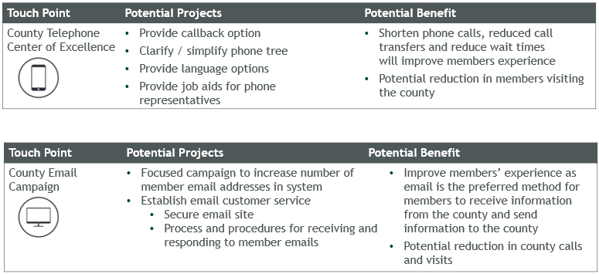
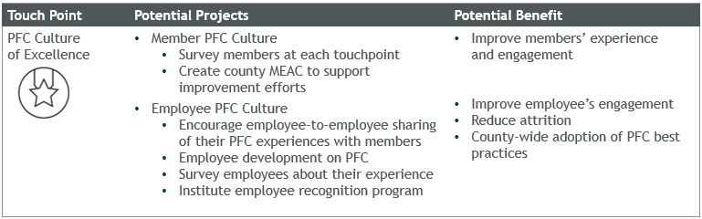
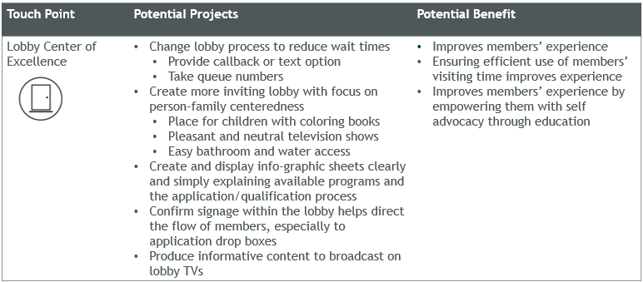

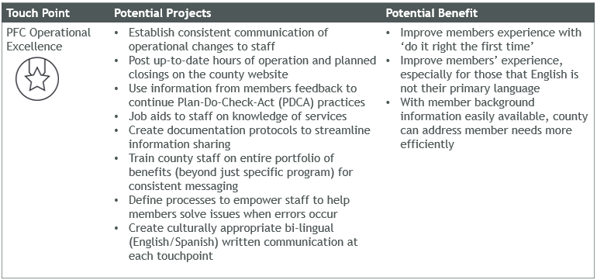

Appendix B: HCPF’s Member Experience Council Journey and Outcomes
Creating a Culture of Collaboration

History
With grant funding from the Colorado Health Foundation (CHF), the Institute for Patient and Family Centered Care (IPFCC) conducted a three day site visit in 2012 to interview Department staff and stakeholders about person and family-centered care and stakeholder engagement. In December 2012, IPFCC delivered a report with recommendations, entitled Advancing the Practice of Client- and Family-Centered Care for the Colorado Department of Health Care Policy and Financing. The Department used this report to secure funding from CHF to implement several key recommendations, the most impactful being the development of Member Experience Advisory Councils. The Department has begun to implement person-and family-centered practices by involving clients and families as a feedback mechanism to the Department through in-person and virtual advisory councils made up solely of Health First Colorado (Colorado's Medicaid Program) and Child Health Plan Plus members and family members/caretakers.

Current Membership
Our goal is that the Advisory Councils consist of 7-15 members who are currently or were recently enrolled in Health First Colorado or Child Health Plan Plus (CHP+), or who are family members/caretakers of a current Health First Colorado or CHP+ member. The Department seeks individuals who bring personal client experiences and are not actively engaged in working with the Department, formally or informally, in another way. Preference is given to those individuals who do not represent an advocacy organization – either paid or unpaid.

In-Person Advisory Council
We currently have 12 Medicaid and Child Health Plan Plus (CHP+) members or family members and/or caretakers serving on our In-Person Advisory Council.

Logistics
- In-person meetings no more than once a month.
- Gift card stipends and compensation for travel and childcare are available.
- Advance preparation includes reviewing the agenda and meeting materials.
- Between-meeting work includes email communication.
- Members may also be asked to provide feedback through email, surveys or other online forums.
Virtual Council
In order to accommodate interested members unable to travel to our monthly meetings in Denver, we implemented a Virtual Advisory Council in October 2015. The Virtual Council is currently made up of 14 members.

Logistics
- Virtual meetings, no more than once a month. (In-person meetings are not required.)
- Gift card stipends for participation are available.
- Virtual Advisory Council members provide feedback through email, surveys and other online forums within 10 business days from request.

Topics and Input by the Numbers
To date, In-Person and Virtual Advisory Council members have provided input on
- 174 discrete projects, documents, or topics:
  - Eligibility correspondence (notice of action, redetermination letter, explanation of benefits, etc.)
  - Other communication (Non-Emergent Medical Transportation (NEMT) brochure, communication plan around the uncertainty of CHP+ in 2017, surveys, video scripts, etc.), State Innovation Model (SIM) patient education materials
  - Customer journey mapping for Medicaid
- 51 topics were reviewed in 2017
- 31 HCPF staff attended in-person meetings
- 11 external partners attended from 8 different organizations

Outcomes
CHP+ Communication Plan
Because of the community of trust we’ve created in the Council, we’ve been able to bring sensitive topics to the group for input. With the uncertainty of continued funding for Child Health Plan Plus (CHP+) in late 2017, we had an opportunity to get our members involved in shaping our communication plan very early. Due to the direct impact of their feedback, Colorado was the first state in the nation to communicate about the potential end of funding for Child Health Plan Plus (CHP+)

Member Handbook
We approached the Council a couple years ago with an opportunity to develop a new Member Handbook from scratch. Council members provided input on content, organization, format, accessibility and more. Our Member Handbook is now published on our website and recently won an Award of Distinction from the Center for Plain Language.

Correspondence
Because of the work the Council has done on Department correspondence since 2015, we are engaged in a larger project to overhaul client correspondence which we expect will help our members understand their benefits and responsibilities and reduce call volume to counties and our call center.

2017 End of Year Report
More information

Appendix C: Member Experience Advisory Council Development Grant Application Process
Grant applications will be released on May 14, 2018 and will be due to the Department no later than close of business June 29, 2018. Grant applications and any supporting documentation must be submitted to HCPFCountyRelations@state.co.us.

Proposed projects will be scored and Grant Project Manager will be contacted for an interview if there are questions about the application. The Department will issue FY 2018-19 Award Letters to approved proposed projects in early July 2018. Projects can begin once the grantee returns the signed Award Letter to the Department.

Appendix D: Grant Project Scoring Process and Interview
To determine which county applicants will be funded for this project, Department staff will review grant applications prior to conducting an interview with the Grant Project Manager. Each proposal is scored based on the application.

Point Scale
Scores are determined on a three (3) point scale:

1 point – The proposed project did not address the application section satisfactorily; insufficient information was provided to make an adequate determination.

2 points – The proposed project addressed the application section satisfactorily; sufficient information was provided to make an adequate determination.

3 points – The proposed project addressed the application section to an exceptional level of detail to make an adequate determination.

Application Sections Score
The following sections of the application are worth a maximum of three (3) points each:

- Part II, Project Need – Description of how a Member Experience Advisory Council would benefit of your county. Including description of county’s unmet needs for member input and how this project will address those needs, and examples of areas of county operations that could be addressed or improved by this project.

- Part III, Data and Metrics – Description of data and metrics that will be tracked to identify the project’s success

The following section of the application is worth a maximum of six (6) points each; two times (2x) the scaled rating above:

- Part VI – Description of how will the county determine project success and how it will identify areas for improvement and how the project will be sustained without funding from the Department.

Total Score
The applicant’s total score is based on the table below; applicants with the highest scores will be funded first until all available funding is exhausted.
Section Scored | Maximum Points
Part II – Project Need | 3
Part III – Data and Metrics | 3
Part VI – Sustainability | 6
Maximum Score | 12

Appendix E: County Grant Program Conditions of Funding

Acceptance of Conditions of Funding
By completing and submitting the Member Experience Advisory Council Development Grant Application, the applicant is agreeing, if accepted for participation, to abide by the County Grant Program Conditions of Funding and Department finance rules as stated in 10 CCR 2505-5.

Conditions of Funding specific to this project can be found below. Additional conditions of funding, if applicable, will be listed on the applicant’s Award Letter. All Conditions of Funding must be met to be eligible for funding of this project. Failure to comply with the Conditions of Funding may result in disallowances, per Appendix E, Audits and Sanctions.

Project Conditions of Funding
Project deliverables and requirements must be complete no later than March 15, 2019.

Grantees are required to submit Quarterly Reports (template provided by the facilitator), and a Final Report (template may be provided by the facilitator). Failure to comply may result in disallowances per Appendix E, Audits and Disallowances.

To fulfill the requirements of the Quarterly Reports and Final Report, the grantee must submit these reports no later than the following deadlines.

FY 2017-18 Quarter | Deadline to Submit Reports
Quarter 1  July 1 - September 30 | October 15, 2018
Quarter 2  October 1 – December 31 | January 15, 2019
Quarter 3  January 1 – March 31 | March 15, 2019

For the Development Workshop requirement, grantees should include travel costs for the Grant Project Manager and one (1) additional staff per participating County to travel to and stay in Denver, CO in August 2018. Please note that State fiscal travel rules must be followed in funding requests for travel for the Development Workshop.

A Final Report must be submitted to the Department no later than close of business March 15, 2019. The Final Report can vary, but should include a final itemized budget with actual costs and any outcomes using a template the Department may provide.

Budget Conditions of Funding
Grant funds will only be used as specified in the approved grant proposal unless otherwise approved and documented by the Department. No other expenditures other than those directly tied to the proposed project are allowed.

Indirect costs are not allowable expenses in the Itemized Budget and will be denied.

Reimbursement of expenditures related to this grant will be paid on a quarterly basis.

All expenditures associated with the approved grant proposal must occur on or before March 15, 2019; expense reimbursements requested after June 15, 2019 will not be reimbursed.

Proposed projects can be based on estimates of costs. Actual costs may require budget flexibility in the Itemized Budget. Funds may be moved from one line-item to another in these instances but will require an updated Itemized Budget be submitted with the Quarterly reporting. However, total funding for any Council may not exceed the $8000 per Council and $1000 per participating County for travel expenses for 2 participants to attend the Development Workshop. Any project expenditures above these amounts must be paid for with county-only funds.

Audits and Sanctions
Records are required documenting all expenses and accounting for the uses of all grant funds.

All tasks and expenditures associated with the proposed project are subject, at any time and without prior notification to the grantee, to audit by Department staff and/or an external auditor, per 10 C.C.R. 1.010.8.C, Audits by the Colorado Department of Health Care Policy and Financing.

Failure to comply with any oversight requirements as listed in Appendix E, Conditions of Funding, are subject to County Administrative Rules as stated in 10 C.C.R 1.020. If the grantee fails to comply with 10 C.C.R. 1.010.8.C, 10 C.C.R. 1.020, or any requirement listed in Appendix E, County Grant Program Conditions of Funding or the Award Letter, the Department may, at its discretion, and only after the remedies described in 10 C.C.R. 1.020 are exhausted, subject the grantee to disallowance per 10 C.C.R. 1.020.2, Sanctions. The Department’s decisions based on requirements in Appendix E, Audits and Sanctions, are final and not subject to appeal.

